Profile: GHANA
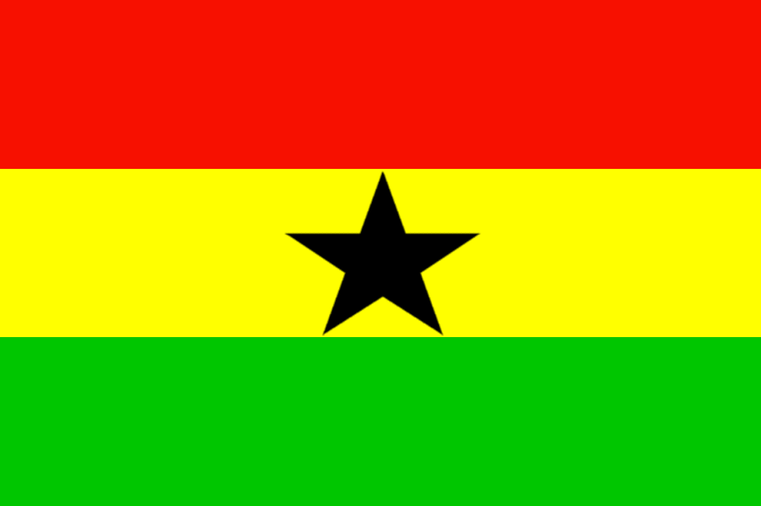

This is a profile of GHANA. It is the MIDDLE country in the WEST AFRICA. The GDP of GHANA is approximately 48.14 billion dollars per year.

Exports | %
GOLD | 25
PETROLIUM | 10
COCOA | 6
AGRICULTURE | 4
ORE | 3

Regional Economies
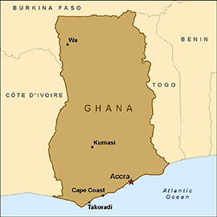
Country | GDP | Main Exports
NIGERIA | 521.80 billion | AGRIC, OIL, TOURISM,TRANSPORTATION, MINING
GHANA | 48.14 billion | GOLD, PETROLEUM, COCOA, ORE, AGRIC
TOGO | 8.684 billion | AGRIC, INDUSTRY, OIL, ELECTRICITY
SIERRA LEONE | 104.15 million | FISH, COCOA, COFFEE

The regional economy is strong. The region is dominated by NIGERIA. However, the other countries in the region are strong. GHANA is behind the other countries in exports and GDP.

