FU: Capitalism and Investment

Misconception:

Americans and Europeans are richer because they work harder, are smarter, and are superior to everyone else.

Are white people smarter than everyone else?

“White” countries have the best economies in the world. Well, if we look at statistics, this isn’t 100 percent true: Asian countries are pretty rich nowadays.

But it’s almost true if we look 100 years ago. Europe and the US) ended up richer than the rest of the world? So why?
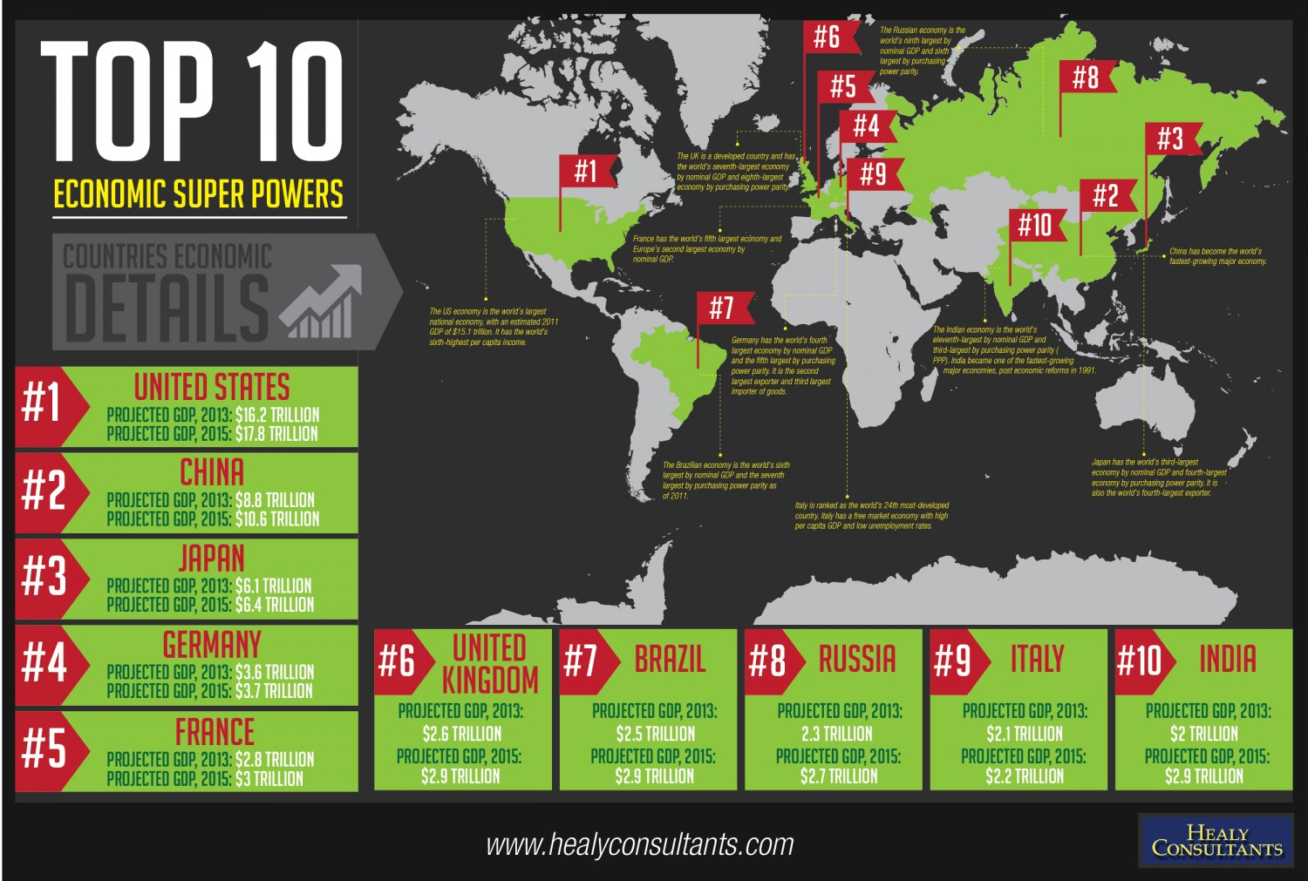
There is no simple answer. But, if you want a simple answer, then:

Europe and the US got rich because of capitalism. Capitalism is an economic system where people invest money in new things. People invest their money in companies and the best companies grow and grow. As they grow and grow, they create jobs. So, people get richer and richer with the country.

So, let’s talk about investment!

Complete

1. What is a common misconception about white people and economics? Europe and the US got rich because of capitalism.

2. Look at the chart of economic power; Is it true that only Europe and the US are powerful? YES

3. What is capitalism? Capitalism is an economic system where people invest money in new things.

True/False

_YES___ Capitalism is an economic system

___YES_ Capitalism is based on investment

Misconception:

The best way to get rich is to save money.

The Best Way to Make Money is to INVEST money!
People tell you to be smart and put your money in the bank. But that’s NOT the way to GET RICH!

Remember we studied mercantilism. Spain in the 1500s was mercantilist. They tried to get as much gold as possible and not spend it. This didn’t work. Spain went from the strongest to the weakest world economy. The best way is to invest in other businesses and build production capabilities.

Rewrite

1. The best way to make money is to save. The best way to make money is to invest money

2. Mercantilism is a great system for building a strong economy. YES

Complete

3. When you invest in business, you build ____CAPITALITIES___________.

True/False

1. Your true economic power is your production capability. YES

Elias Tortilla Co

Here’s an example. Elias has a great tortilla recipe. He makes the most delicious tortillas. He wants to make a business.

He goes to the bank with his plans. He borrows 500,000 dollars. He starts a little shop making tortillas. Things are great! Everyone loves his tortillas. He makes enough to pay off the bank. Does he?

No, instead of putting it in a bank, he talks to some rich guys. These guys are investors. They love his tortillas. They invest 5 million dollars in his company. So, Elias buys a tortilla factory. He gets it really cheap and installs the best technology.

Now Elias Tortilla Co. is making the most delicious tortillas.
Elias makes enough in a year to pay everyone back and start saving. Does he start saving?

No! Instead of keeping that money, Elias buys some restaurants that serve his tortillas. He has to borrow more money from the bank to do this. He borrows 10 million from the bank and investors. He opens up: Elias Tortilla Cantina. It opens all over Virginia. It’s a success!

Now, Elias has borrowed much more money than he has made. But he has a successful business. He buys some trucks and warehouses. He starts selling his own brands of pupusas, injera, chilaquiles, white bread, and spices.

After 10 years, Elias Co is worth 10 billion dollars. He started with a small loan of 500,000. He didn’t stop at the tortilla shop. He didn’t stop at the factory. He kept getting more investments and putting it into his corporation.

Summarize

1. How does Elias make his company grow:

First, He borrows 500,000 dollars from the bank.
Second, he talks to some rich guys. These guys are investors. They love his tortillas. They invest 5 million dollars in his company.
Third, Elias buys some restaurants that serve his tortillas. He has to borrow more money from the bank to do this. He borrows 10 million from the bank and investors.
Fourth, after 10 years, Elias Co is worth 10 billion dollars. He started with a small loan of 500,000. He didn’t stop at the tortilla shop. He didn’t stop at the factory. He kept getting more investments and putting it into his corporation.

…

Misconception:

Countries are RICH because they HAVE all the Money

In 1776, a man named Adam Smith wrote a book called the Wealth of Nations. At this time, people believed in Mercantilism. People believed the best way for a country to become rich was to save as much gold as possible.

We learned that the best way to MAKE money is to INVEST money. .
Adam Smith invents an idea called capitalism. The central ideas of capitalism are:

1. How Rich a Nation Is = How Much Businesses Produce

2. Comparative Advantage: Nations Shouldn’t be Self-Sufficient. They Should Produce What they Can Best

3. Governments Shouldn’t Interfere in the Economy

4. Entrepreneurship= Competition = Businesses Survive and Grow because They are the Best

Rewrite
1. The founder of capitalism is ADAM SMITH.
2. Adam Smith invents an idea called capitalism .
3. Adam Smith believed the best way for a nation to get rich was How Much Businesses Produce.
4. The wealth of a nation equals Mercantilism

Complete The foundations of capitalism are:
1. How Rich a Nation | 2. Comparative Advantage
3.  Governments Shouldn’t Interfere in the Economy | 4. Governments Shouldn’t Interfere in the Economy

Wealth of Nations = Production

Apple is based in the USA. Even though most of the I Phone is made in China, the highest paid employees for Apple are from the USA. Why? They design the I Phone. They make the models. They organize the production. They make the software. They do the advertising.

So, Apple is part of the GDP or Gross Domestic Product of the USA. Even when they do business in Asia, the money makes it back to the USA. GDP measures how much companies from a country produce; the GDP of Apple reflects the USA.

Rewrite
- GDP = how much PRODUCT a country has

- Apple is made in China; it is part of China’s GDP. YES

Comparable Advantage = No Self-Sufficiency

The USA produces cars. Cars need tires. Tires require rubber. Rubber trees grow in Brazil.

Should the USA try to grow rubber in Florida so they don’t have to pay Brazil for rubber? Of course, not! Brazil has the advantage so they should make the tires.

We say, no, but before Adam Smith, most economists said yes. Mercantilists wanted self-sufficiency. Capitalists don’t want self-sufficiency. They want trade.

Instead, the USA makes all of the parts of the car where they are cheapest. They make the tires in Brazil. They make the plastic parts in China. They make the metal parts in Mexico. Then, they assemble it together in the USA.

Complete

1. Mercantilists want _______ self-sufficiency ____________, which means that a country doesn’t need to trade to grow.

2. Capitalists want ___ trade.
_________________, where each country produces what it can best produce.

True/False

__YES__ USA has a comparable advantage to produce tires.

___YES_ USA should trade Brazil for the tires
Government Interference versus Competition

Remember Myspace? Blockbuster video? Farmville? These are all business that—at some point—people wanted to invest lots of money in. At some point in time, if you asked someone whether Netflix or Blockbuster video was a better company, they would say “Blockbuster” without a doubt.

Blockbuster had stores. Netflix just had mail-order DVDs. But Netflix adapted. They competed better. They became the better product.

Imagine if we all still used Myspace instead of Facebook. Imagine if the USA government was friends with the guy who owned Myspace. Imagine if the government made a law that said: “Myspace is free but Facebook users have to pay a tax.” This is government interference. It was very common. Adam Smith says: The Government shouldn’t interfere. They should let the economy alone. This is called laissez-faire or let business do what it wants.

Rewrite

1. Adam Smith supports government interference in the economy. The Government shouldn’t interfere. They should let the economy alone.

2. Laissez-faire means that government should interfere in the economy. The Government shouldn’t interfere. They should let the economy alone

Misconception:

Capitalism helps everyone right away.

Remember my example about the car? Or the I Phone? Think about it: Who is doing most of the physical work for I Phone? The Chinese. Who is making most of the money? The Americans.

Capitalism is going to benefit the countries that industrialize first. Our original question is why Europe and US are rich. The reason is that they adopt capitalism and industrialize before the rest of the world. They get a head start.

Capital = money, technology, and people for your business

Here’s the ideas of capitalism:
Money | Don’t save it; invest it in your business | Grow, grow, grow!
Technology | Don’t be happy with your technology: come up with better ways to make even more money! | Research, research, research!
People | Workers = business costs = the lower wages, the better | Efficiency, efficiency, efficiency!

So are white people smarter than everyone else?

No, but in the early 1800s, English people are better capitalists than everyone else… And then Americans. And Germans.

England is going to start the Industrial Revolution. We have talked about the French, America, Haitian, Latin American, and Russian Revolutions.

They are NOTHING compared to the Industrial Revolution.

Rewrite

1. Europe and the United States are rich because they saved their money instead of investing.

2. Investing your money is part of an economic system called CAPITALISM.

3. The founder of capitalism is named ADAM SIMTH

4. Investing in what your country does well—like Brazil making tires—is called laissez faire.

5. Adam Smith DON’T WAN’T the government to interfere with the economy. This is called Laissez-Faire economics.
6. The Wealth of a Country is how much it INVESTED.

7. Mercantilism IS DEFFERENT FROM capitalism.

8. MERCANTILISM want self-sufficiency and gold.

9. CAPITALISM want investment and free trade.

